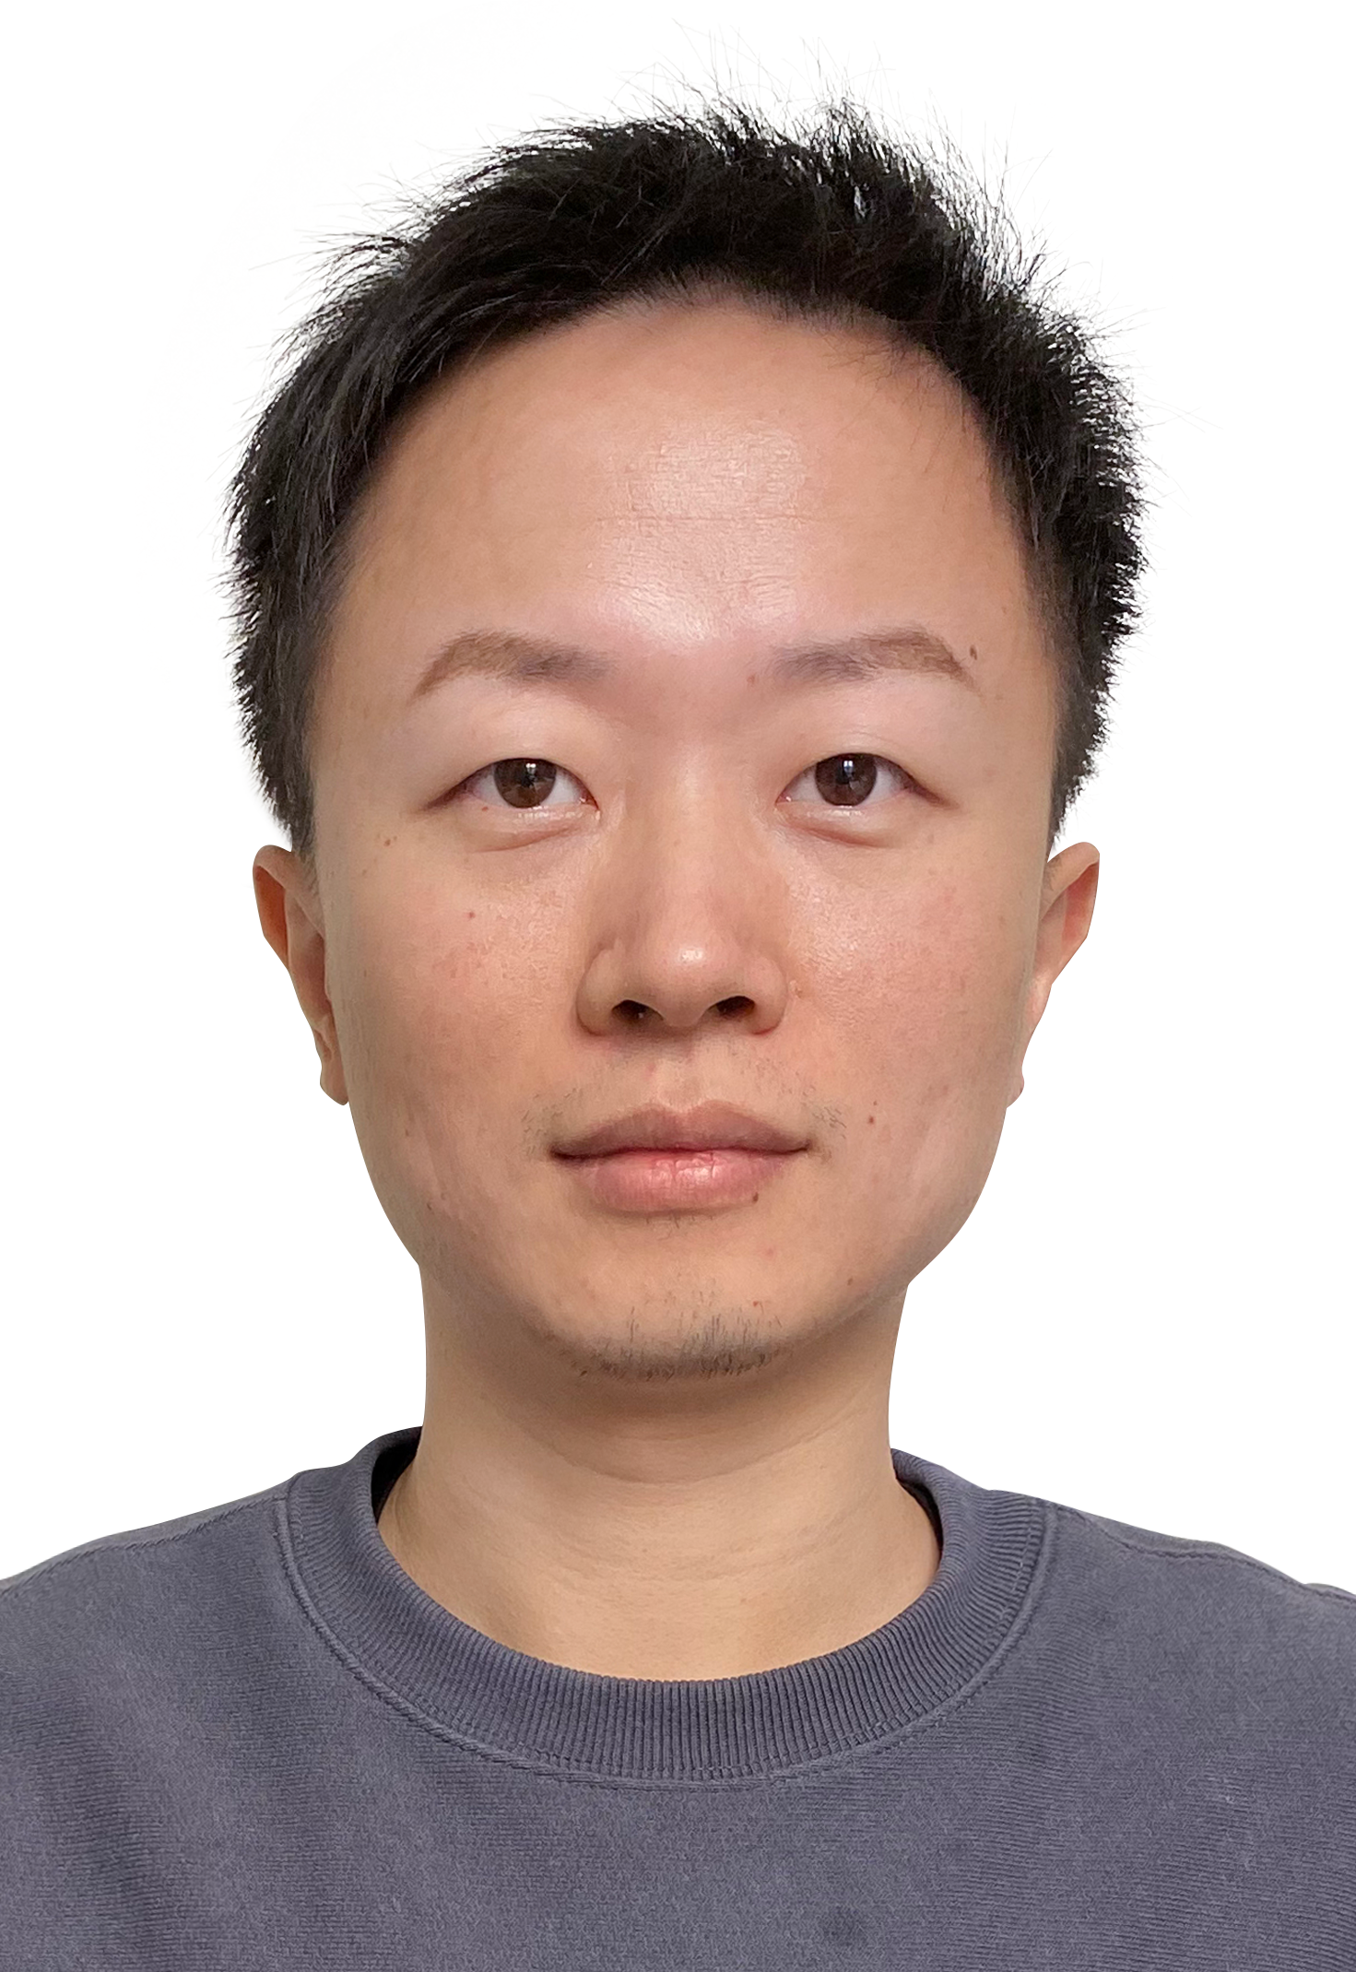

**Dr. Yuchen LU**   
Data Analyst

*Immediate availability*

[simondeqin@gmail.com](mailto:simondeqin@gmail.com)

+33 7 83 07 63 61

[LinkedIn](https://www.linkedin.com/in/yuchen-lu-data-analyst/)

[GitHub](https://github.com/simondeqin)

75015 Paris, France

Competences

Technical Skills

* Python
* MySQL
* Tableau
* Machine Learning
* Git
* Excel
* Azure

Soft Skills

* Curiosity
* Adaptation
* Problem-solving
* Communication
* Reporting
* Resilience

Languages

* French – Fluent
* English – Fluent
* Chinese – Native

Personal Interest

* CityWalk
* Board Games
* Travelling
* Investment

Profile

* Inspired by a digital humanities project during my postdoc, I transitioned to data science. Skilled in analytical tools, I aim to turn data into valuable insights for decision-making.
* My background in sociology and history endows me with strong analytical acumen, effective data management, and reporting skills, while fostering a passion for continual learning.

Projects

[Analysis of the Investment of Warren Buffet](https://github.com/simondeqin/Final_Project/tree/main)

Concluding my bootcamp at Ironhack, the project was unanimously praised by the jury:

* **Data Collection**: Utilizing Yahoo Finance API for data extraction
* **Data Cleaning and Feature Engineering**: Employing Python, especially pandas and numpy, for data processing and structuring
* **Exploratory Data Analysis and Exportation**: Conducted using Python with libraries like matplotlib, seaborn, and sqlalchemy
* **MySQL Utilization**: Creating an Entity Relationship Diagram and performed advanced analyses on portfolio, moving averages, and monthly performance
* **Predictive Modeling for Stocks**: Developing Machine Learning models, particularly linear regression

Experiences

Postdoctoral Affiliation 03/2022 – 02/2023

Institut Français de Recherche sur l’Asie de l’Est (IFRAE – UMR 8043)

* Qualification of Maître de conférences in Sections 15 et 22
* Project in Digital Humanities – “Elites, Networks and Power in Modern China”, ENP·China

Publications and Contributions

• Two articles in the *Chinese Journal of Sociology* (2019) and *the Journal of the Oxford Centre for Buddhist Studies* (forthcoming) • Six presentations at Parisian and international conferences

Education

Bootcamp Data Analytics (+400h) 04/2023 – 06/2023

Ironhack (Paris), intensive on-site courses

2 Level +6 Certifications (equivalent to Bac +3/4)

* Delivery of 8 projects in Data Analytics and Business Intelligence

PhD in Études de l’Extrême-Orient 03/2022

École Pratique des Hautes Études, PSL University (Paris)

Master in Sociology 09/2013

University of Strasbourg (Strasbourg)

* “France Excellence” – Master Scholarship by the French Embassy in China

Bachelor in Sociology 06/2011

Peking University (Chine)

* 1e ranking in China, 12e worldwide (the QS World University Rankings 2023)